Assesssment 1 - COVID-19 impact on digital learning

Student Name and ID

2023-03-10

## Data Cleaning and Wrangling

**Describe and show the data cleaning and wrangling process’ that you have completed. Provide justification on any transformation you have completed.**

you can embed your code like this:

x <- 1:10 # create an x variable  
y <- 10:1 # create a y variable  
dataf <- data.frame(x = x, y = y)  
  
summary(dataf)

## x y   
## Min. : 1.00 Min. : 1.00   
## 1st Qu.: 3.25 1st Qu.: 3.25   
## Median : 5.50 Median : 5.50   
## Mean : 5.50 Mean : 5.50   
## 3rd Qu.: 7.75 3rd Qu.: 7.75   
## Max. :10.00 Max. :10.00

## Data Visualisation

**Provide evidence of your visualisation techniques and the reason for your choice of visual tools.**

You can also embed plots, for example:

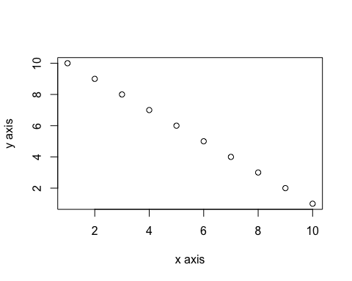

## Findings

**Clearly explain your findings and provide a valid conclusion of your analysis.**